DockingTab Overview
The C1DockingTab control implements the familiar tab control interface, where several overlaying pages (each of which contains arbitrary controls) are accessible via tabs at the side of the control.

In addition to this standard behavior, C1DockingTab also provides docking and floating behavior, where the whole control, or individual pages (tabs) can be torn off and automatically docked to one of the other sides of the form, to another C1DockingTab control, or floated in a separate tool window. To enable the docking and floating behavior of the C1DockingTab control, it must be placed inside a C1CommandDock. For more information, see Enabling DockingTab Docking and Floating.

See Also

DockingTab Appearance and Behavior Properties

DockingTab Appearance and Behavior Properties
C1DockingTab provides a number of useful properties to control the behavior and appearance of the tab items.

C1DockingTab includes a variety of appearance properties to visually enhance and customize the control. The control's tab style, size, and layout can easily be customized through the C1DockingTab's appearance properties. These properties can be set at design time through the Properties window or through code.

In addition to the appearance properties, C1DockingTab has several useful behavioral properties for closing tab pages, rearranging tabs, and mouse over effects for tab pages.

The following section introduces some of the common appearance and behavior properties used for the C1DockingTab control.
See Also

DockingTab Visual Styles Docking Styles
Tab Styles

Tab Sizing

Tab Orientation Text Orientation
Hiding, Closing, and Moving Individual Tab Pages Mouse-Over Styles in Tab Pages

DockingTab Visual Styles
The C1DockingTab control provides several built-in styles, such as Custom, System, Office2010Blue, Office2010Black, Office2010Silver, Office2007Blue, Office2007Black, Office2007Silver, Office2003Blue, Office2003Olive, Office2003Silver, OfficeXP, Classic, and WindowsXP that can be easily applied using the VisualStyle property.

The following table illustrates each of the C1DockingTab control’s visual styles.

Property Setting | Image
VisualStyle.Custom | [Custom allows you to customize the control’s visual style]
VisualStyle.System | 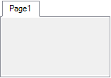

VisualStyle.Office2003Blue
VisualStyle.Office2003Olive
VisualStyle.Office2003Silver
VisualStyle.OfficeXP
VisualStyle.Classic | 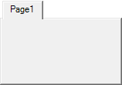
VisualStyle.WindowsXP | 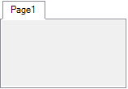

VisualStyle.Office2007Blue
VisualStyle.Office2007Black
VisualStyle.Office2007Silver | 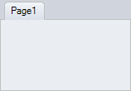
VisualStyle.Office2010Blue
VisualStyle.Office2010Black
VisualStyle.Office2010Silver

Docking Styles
When the C1DockingTab control is placed in the C1CommandDock component (see Enabling DockingTab Docking and Floating), it becomes a dockable control. You can select a specific style for docking by setting the C1CommandDock component’s DockingStyle property to Default, VS2005, VS2008, or VS2010. The Default setting shows a gray shaded outline to illustrate where the control will be docked when you release the cursor, whereas VS2005, VS2008, and VS2010 mimic the docking style of Visual Studio 2005, Visual Studio 2008, and Visual Studio 2010 respectively. The table below provides an example of each docking style.

Docking Style | Example
Default
VS2005 | 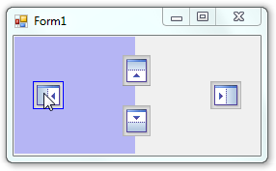
VS2008 | 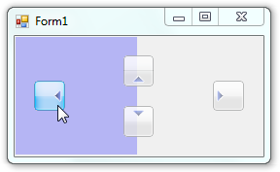

VS2010

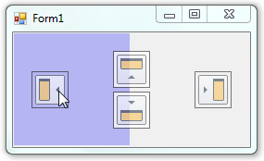Tab Styles
C1DockingTab provides several built-in styles such as Custom, System, Office2007Blue, Office2010Blue, Office2010Black, Office2010Silver, Office2007Black, Office2007Silver, Office2003Blue, Office2003Olive, Office2003Silver, OfficeXP, Classic, and WindowsXP that can be easily applied using the VisualStyle property.

C1DockingTab provides several built-in styles such as Classic, Default, Office2003, Office2007,
Office, 2010, Rounded, Sloping, VS2003, and Windows XP that can be easily applied using
the TabStyle property. You could also choose what type of look you would like for your tab pages. For example, you may want the tab pages to display and image, text, or a combination of both. You can do this by setting the TabLook property to Default, Text, Image or TextandImage.

You could also customize your tab's style using C1DockingTab's general appearance properties such as the C1DockingTab.BackgroundImage, C1DockingTab.BackgroundImageLayout, TabAreaBackColor, TabBackColor, TabBackColorSelected, and TabForeColorSelected.

The following figure illustrates a few of C1DockingTab's general appearance properties:

Figure 1

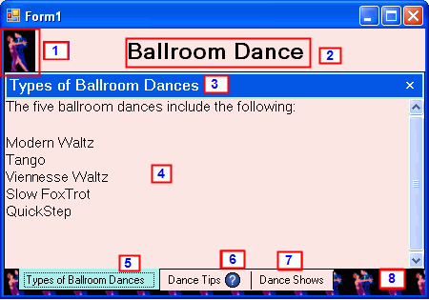

Labels for Figure 1 | Description
1 | PictureBox control
2 | Label control
3 | C1DockingTabPage.CaptionText
4 | RichTextBox control
5 | C1DockingTabPage.TabBackColorSelected = PaleTurquoise
6 | C1DockingTabPage.Image
7 | C1DockingTabPage.TabBackColor = MistyRose
8 | C1DockingTab.BackGroundImage

Tab Sizing
You can customize the width and height of the tab pages by setting its ItemSize to an appropriate value. This will make all the tab pages the same size no matter what the content is inside each tab. Its default settings for its size are based on the size of its text and image. In addition to customizing the height and width of each tab you can also set a mode for the tabs. The TabSizeMode property contains four types of members: FillToEnd, Fit, Normal, and User. The FillToEnd stretches the tabs so they take the whole width of the tab control. The Fit squeezes all tabs so they fit into the width of the tab control. The Normal member gets the default sizing mode. The User member allows the user to specify the tab size in the MeasureTab event. The following table shows the effect of
each TabSizeMode member.

 | Note: The third image in the following table contains only two tab pages to better illustrate the effect of the FillToEnd member.
Property Setting | Image
TabSizeMode.Normal | 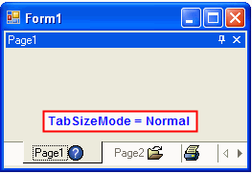
TabSizeMode.Fit | 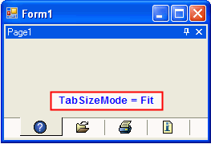

TabSizeMode.FillToEnd | 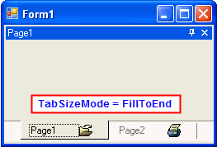
TabSizeMode.User | 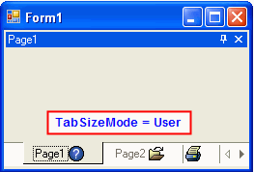

Tab Orientation
C1DockingTab provides various options for the tab orientation. The tabs can be aligned to the top, bottom, left, or right of the C1DockingTab control by using the Alignment property.

The following image displays the tabs aligned at the top of the C1DockingTab.

In addition to choosing the tab layout you can also specify how the tabs are aligned along the side of the page content area by setting the AlignTabs property to Near, Far, or Center.

Note: The AlignTabs will not take effect if the TabSizeMode property is set to Fit.

The following image displays the tabs aligned at the Top and Center of the C1DockingTab control:

If you would like your tabs located at a specific location rather than Near, Far, or Center of the control you can specify exactly where by setting the Indent property to a specific number in pixels. For example the following image depicts the tabs indented to 30 pixels.

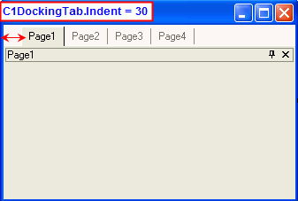

Text Orientation
In addition to determining the layout of the tabs you can also customize the layout of the text in the tabs. You can use the TextDirection property to display the text horizontally, vertically, vertically from right to left, or vertically from left to right. The following table illustrates how the tabs appear when the TextDirection is set to Horizontal, VerticalLeft, or VerticalRight:

Property Setting Image

TextDirection.Horizontal | 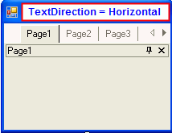
TextDirection.VerticalLeft | 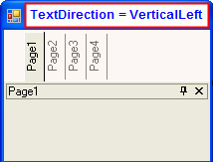
TextDirection.VerticalRight | 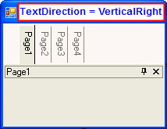
When you have text and an image displayed in the tab you may want to control whether the text is
displayed above, below, to the left or to the right of the image. You can use TabLayout property to set the text above, below, to the left or to the right of the image in the tab.

Property Setting Image

TabLayout.TextOnRight | 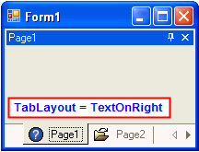
TabLayout.TextonLeft | 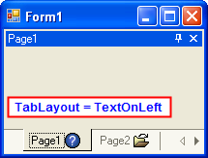
TabLayout.TextAbove | 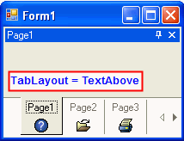
TabLayout.TextBelow | 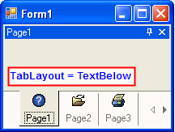

Hiding, Closing, and Moving Individual Tab Pages
The C1DockingTab control includes the following behavioral properties for hiding, closing, and moving tab pages at run time:

- CanAutoHide
- CanCloseTabs
- CanMoveTabs

For your convenience these properties are set to True by default. If you don't want to enable these properties you can set them to False. The following table depicts how the C1DockingTab appears at run time when the CanAutoHide, CanCloseTabs, and CanMoveTabs are set to True.

Action | Result
AutoHide icon clicked | 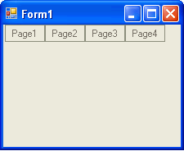
Page1 Close button clicked | 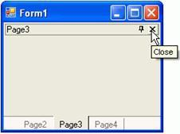
Page1 tab moved | 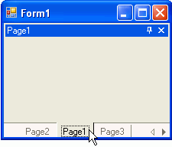

Mouse-Over Styles in Tab Pages
C1DockingTab provides a simple property for applying mouse-over effects to the tabs. When the HotTrack property is set to True at design time or programmatically it changes the tab's appearance when the mouse hovers over it.

