Menus and Toolbars Overview
The C1Command suite integrates menus and toolbars into a single system, allowing you to reuse the same objects and code for menu items and toolbar buttons.

The five main types of objects for building menu systems with C1Command are C1MainMenu, C1CommandMenu, C1CommandControl, C1CommandMdiList, and C1ContextMenu. Whereas, the main types of objects for building toolbar systems are C1ToolBar, C1CommandMenu, C1CommandControl, C1CommandMdiList, and C1ContextMenu. The only difference between the two is the two primary controls: C1MainMenu and C1ToolBar.

C1MainMenu

C1MainMenu is a control that displays the main menu in a Windows forms. When you place this object on your form, it will show across the whole form at the top, as regular Windows main menus do. In addition to the main menu at the top of the form, a C1CommandHolder will automatically appear in the component tray. The C1CommandHolder stores all of the menu's commands as a single collection. For more information on how to use the C1CommandHolder, please see C1CommandHolder Component.

Command links of type C1CommandLink are used to represent the commands in menus.

C1ToolBar

C1ToolBar is a control which represents a toolbar. Like the C1MainMenu it contains a collection of command links stored in the C1CommandHolder component. The command links represent menu items on the main menu bar whereas the command links for C1ToolBar represent buttons on the toolbar.

The following topics provide further detail about the functionality of menus and toolbars and the common and unique objects used to create the menus and toolbar systems.

See Also

Menus and Toolbars Functionality

Common Objects Used to Create Menus and Toolbars Unique Objects Among Menus and Toolbars
Menus Appearance and Behavior

Toolbars Appearance and Behavior

Menus and Toolbars Functionality
The functionality of a menu item and a toolbar button is very similar in C1Command. The menu item or toolbar button is split between two components: a command and a command link.

Functionality of a C1Command Component

The command (an object of type C1Command or derived types, see Class Hierarchy for a list) is used to hold properties and event handlers related to the actual action which the command represents. Commands themselves are not contained in C1Commands menus and toolbars. Instead, all commands on a form are stored as a single collection in a component of type C1CommandHolder, a single instance of which is automatically created on the form when you add the first C1Commands menu or toolbar to it.

For more information on how to use C1CommandHolder, please see C1CommandHolder Component. To represent commands in menus and toolbars, command links (components of type C1CommandLink) are used.

Functionality of a C1CommandLink Component

A command link is a small and quite simple component. Its most important property is Command, which points to the actual command object associated with this command link. Aside from this, a command link allows you to override some of the properties of the linked command, such as text. The visual representation of a command link depends on two factors: the command it links to and whether the link is contained in a main menu, a popup menu, or a toolbar.

Properties used to show the command link are taken from the command, for example text or image, whereas the way they are shown is determined by the container. In a main menu, only the command’s text is shown and in a popup menu the image and the shortcut are also shown, and so on. Multiple command links can point to the same command, which is one of the main reasons why commands and command links are separate items.

Relationships Among Commands, Command Links, Menus and Toolbars, and Command Holder

To sum it up, the following relationships exist between commands, command links, menus and toolbars, and the command holder on a form:

  - Commands (class C1Command and derived classes) are automatically stored in the form’s command holder (object of type C1CommandHolder).
  - Menus and toolbars (objects of type C1MainMenu, C1CommandMenu, C1ContextMenu, C1ToolBar) contain command links (type C1CommandLink) which represent menu items or toolbar buttons. Each command link points to the actual command in the command holder.

Command links are stored in the CommandLinks collection of a menu or a toolbar. Command links can be edited via this collection or using the designer.
  - Multiple command links can point to the same command. And command links pointing to the same command can be inside different containers. For example, a link from the File menu and another from the File Operations toolbar can point to the same file open command.
  - Most properties of a command link visible to the user (text, image, and so on.) are normally taken from the linked command. The shown state of the command link (enabled/disabled,
checked/unchecked and so on.) is also determined by the corresponding state of the linked
command (command links do not have state properties).
  - Most importantly, event handlers that actually perform user-defined actions (for example, opening a file or copying to the clipboard) are associated only with commands and never with command links. When a menu item is selected or a toolbar button is clicked by the user, the click event handler of the linked command is invoked.
  - To enumerate all commands defined on a form, use the Commands collection of the command holder (which shows up in the component tray of the form). You can also use the collection editor to add or remove commands (although an easier approach is probably to use the menu or toolbar designer, accessing commands via their links).

Common Objects Used to Create Menus and Toolbars
C1Command's Menus and ToolBars use the following objects to create menu or toolbar systems:

  - C1CommandHolder component
  - C1CommandMenu command
  - C1ContextMenu control
  - C1CommandControl command
  - C1CommandMdiList command

The following section introduces each command or component used in creating menus and toolbars.

See Also

C1CommandHolder Smart Tag C1CommandMenu Command C1ContextMenu Control C1CommandControl Command C1CommandMdiList Command

C1CommandHolder Component
C1CommandHolder is a container for commands. It may also contain an image list for commands' images, and a few other general settings. Only one C1CommandHolder can be placed on a form.

Whenever a C1Command is created, it is always added to the form's command holder. If no commands exist, it will be automatically created by the command's designer.

Command holder provides the following features:

  - It is also an IExtenderProvider providing a C1ContextMenu property to all controls on the form.
  - Provides idle-time automatic update of commands' status such as visible, enabled, checked and so on

C1CommandMenu Command
The C1CommandMenu component is a command (derives from the C1Command base class) that is a menu. In addition to other C1Command properties, it contains a collection of command links which are the menu items of this menu. C1CommandMenu can be included in another menu as a sub-menu.

When a new C1CommandMenu is created, an empty command link is automatically added to it in the same way as an empty command link was automatically added to the new main menu.

For more information about using the C1CommandMenu command, please see Menu Tasks.

C1ContextMenu Control
The C1ContextMenu component is a menu (it derives from the C1CommandMenu base class) that can be attached to an arbitrary control as a context menu. To facilitate this, the C1CommandHolder (which always exists on a form using C1 menus) is an IExtenderProvider providing a C1ContextMenu property of the type C1ContextMenu to all controls on the form.

Note that a C1ContextMenu can be used in other menus in exactly the same way as its base class C1CommandMenu. Thus if you want to use the same menu as a submenu in the main menu system and as a context menu, just link C1CommandLink to the same C1ContextMenu in both places.

For more information about using the C1ContextMenu, please see Context Menu Tasks.

C1CommandControl Command
C1CommandControl is a command which can be associated with an arbitrary control. This functionality is provided by the class C1CommandControl, derived from C1Command. Controls can be dragged from the Visual Studio Toolbox and dropped onto a C1MainMenu or C1ToolBar. This automatically creates a C1CommandControl, connects it to the dropped control, and adds a link to the new command to the toolbar. This command allows at most one command link to be connected to it.

Note: A small control can be added inside it, but it does not handle large controls such as containers.

For more information about using C1CommandControl, see Adding an Arbitrary Control to the Toolbar.

C1CommandMdiList Command
C1CommandMdiList component is a command which, at run time, expands to a list of items corresponding to the MDI child windows of the current window. Note that this is not a submenu. You can either put this command in a submenu all by itself, or add other menu items before or after it.

The following image shows how the C1CommandMdiList displays a list of items corresponding to the MDI child windows.

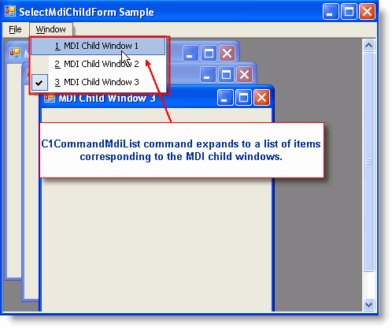

You can restrict the amount of items the C1CommandMdiList command displays in its Menu's list by setting the MaxItems to the desired amount of items you would like to show. The default value for this property is 10.

You can also show hidden MDI windows in the menu's list by setting ListHidden to True.

For more information on how to accomplish creating a Window list for MDI child windows, see
Creating a Window List for an MDI Form.

Unique Objects Among Menus and Toolbars
Menus and ToolBars share many objects, however, there are two distinct components among them. The menus have a C1MainMenu control which is the main menu and the toolbars have a C1ToolBar control which represents the toolbar.

The following section introduces the C1MainMenu and C1ToolBar controls and provides further information about their appearance and behavior properties.

See Also

C1MainMenu Control C1ToolBar Control

C1MainMenu Control
C1MainMenu is a control that displays the main menu in a Windows form. When you place this object on your form, it will show across the whole form at the top, as regular Windows main menus do. In addition to the main menu at the top of the form, a C1CommandHolder will automatically appear in the component tray. The C1CommandHolder stores all of the menu's commands as a single collection. Only one C1MainMenu control can be added to a form.

To add the C1MainMenu control at design-time:

In the Visual Studio Toolbox, double-click on the C1MainMenu component or drag and drop it onto the form.

To add the C1MainMenu control programmatically:

To write code in Visual Basic

Visual Basic | Copy Code
Imports C1.Win.C1Command
Dim ch As C1CommandHolder(Me) Dim mm As New C1MainMenu Me.Controls.Add(mm)

To write code in C#

C# Copy Code

using C1.Win.C1Command C1CommandHolder.CreateCommandHolder(this); C1MainMenu mm = new C1MainMenu(); this.Controls.Add(mm);
The following screen shot depicts a C1MainMenu control once it’s been added to the form:

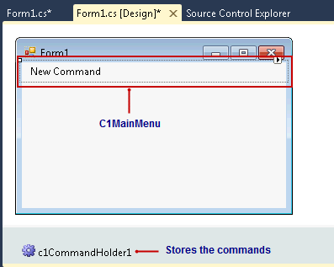

The C1MainMenu control includes a Link to Command designer that conveniently allows you to visually configure the menus.

Note: This editor is available for all C1CommandLinks; therefore, you can easily edit all command links for any of the objects: C1ContextMenu, C1ToolBar, and C1OutBar.

For more information about the elements in the Link to Command designer see Link to Command Designer.

For more information that shows how to use the C1MainMenu control for specific tasks, see Menu Tasks.

C1ToolBar Control
The C1ToolBar control is used on forms as a toolbar. When you place this object on your form, like the C1MainMenu, a C1CommandHolder will automatically appear in the component tray. The C1CommandHolder stores all of the command links as a single collection. The command links

represent menu items on the main menu bar whereas the command links for C1ToolBar represent buttons on the toolbar.

Once the component C1ToolBar is added to the form, the Link to Command designer allows you to set up the toolbar system. C1ToolBar and C1MainMenu both use the same Link to Command designer. For more information about the interface for the Link to Command designer, see Link to Command Designer.

The C1ToolBar provides two different types of toolbars: a default toolbar and a drop-down style toolbar. The toolbar buttons provide drop-down buttons for a drop-down menu. The buttons can be arranged vertically or horizontally on the toolbar depending on the orientation of the toolbar.

For more information on how to use the C1ToolBar control to do specific tasks such as wrapping text in the toolbar button, see ToolBar Tasks.

Menus Appearance and Behavior
Menus provide a number of useful properties to control the behavior and appearance of the main menu and menu items.

C1Command's menus include a variety of appearance properties to visually enhance and customize the control. The menu's style, size, and layout can easily be customized by using the C1MainMenu's appearance properties. These properties can be set at design time through the Properties window or programmatically.

C1Command's menus also include several useful behavioral properties for wrapping, merging, and showing ToolTips in menu items.

The following section introduces some of the common appearance and behavior properties used for the C1MainMenu control.Menu Visual Styles

See Also

Menus Visual Styles

Look and Feel of Menu Items Special Side Caption Styles in Menus Mouse-Over Styles in Menu Items Merging Menus
Layout and Text Wrapping in Menus ToolTips in Menus

Menus Visual Styles
The C1MainMenu and C1ContextMenu controls provide several built-in styles, such as Custom, System, Office2010Blue, Office2010Black, Office2010Silver, Office2007Blue, Office2007Black, Office2007Silver, Office2003Blue, Office2003Olive, Office2003Silver, OfficeXP, Classic, and WindowsXP that can be easily applied using the controls’ VisualStyle properties.

The following table illustrates each style of the C1MainMenu control. The C1ContextMenu control’s visual styles are identical to the C1MainMenu control’s, only the C1ContextMenu control doesn’t contain the menu bar.

Property Setting | Image
VisualStyle.Custom | [Custom allows you to customize the control’s visual style.]
VisualStyle.System | 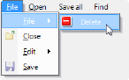
VisualStyle.Office2003Blue | 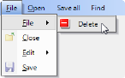
VisualStyle.Office2003Olive | 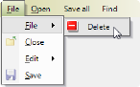
VisualStyle.Office2003Silver | 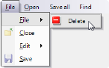

VisualStyle.OfficeXP | 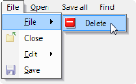
VisualStyle.Classic | 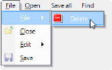
VisualStyle.WindowsXP | 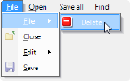
VisualStyle.Office2007Blue | 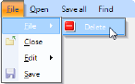
VisualStyle.Office2007Black | 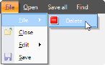
VisualStyle.Office2007Silver | 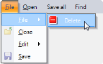
VisualStyle.Office2010Blue | 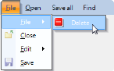

VisualStyle.Office2010Black
VisualStyle.Office2010Silver | 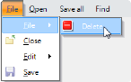

Look and Feel of Menu Items
C1Command supports various settings for font style, border style, back color, and mouse-over styles for the menu items.

You can set the text name for the toolbar button/command either in the command object as well as in its command link. However, the C1CommandLink.Text property overrides the C1Command.Text property.

Special Side Caption Styles in Menus
C1Command has a special SideCaption property for its C1CommandMenu command type. With this property, you can display a side caption along the sub menu items for a particular C1CommandMenu. You can display text or an image inside the caption. In addition to having text or an image in the side caption, you can also customize the appearance and layout of the caption.

The following image shows a vertical side caption for the Field Trips menu.

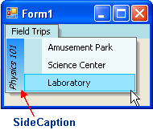

For information on how to apply a side caption to your menu, see Creating a Side Caption for a Command Menu.

Mouse-Over Styles in Menu Items
You can apply mouse over techniques to the menu items to improve your menu interaction with users.

The C1MainMenu component has two special properties for applying mouse-over techniques.
The BackHiColor property gets the back color of the menu item when you hover your mouse over it and the ForeHiColor gets the fore color of the menu item when you hover your mouse over it.

For more information about how to use these properties, see Modifying the Appearance of the Menus.

Merging Menus
In some cases, when you need to merge a MDI child window with a MDI parent menu you can enable the CanMerge property. You can also specify the type of behavior for the merging menu with its MergeType property. You can determine whether to add, replace, remove, or merge menu items with the MergeType property. The MergeItems causes the command links on the menus to be merged.

The command links for both menu items and toolbar buttons have a MergeOrder property which can be used to determine the order of the merged menu items or toolbar buttons.

For more information about how to accomplish merging menus see, Merging Menu Items.

Layout and Text Wrapping in Menus
C1MainMenu has an automatic layout. The menu items are automatically sized.
C1MainMenu's Wrap property enables line-wrapping in the main menu bar. If there are too many items on the main menu bar to fit onto one line it will be wrapped.

ToolTips in Menus
A ToolTip is used to display text when the mouse hovers over the control. C1MainMenu provides a ShowToolTips property that displays the value of the Text property as a ToolTip for each menu item. This property is enabled by default.

If you would like to enter custom text for the ToolTip of each menu item you can through setting the ShowTextAsToolTip to False, and then setting custom text for the ToolTipText property.

For more information how to use the ToolTips, see Displaying ToolTips for Menus and Toolbars.

Toolbars Appearance and Behavior
C1ToolBar provides a number of useful properties to control the behavior and appearance of the toolbars and toolbar buttons.

C1ToolBar includes a variety of appearance properties to visually enhance and customize the control. The toolbar's style, size, and layout can easily be customized by using the C1ToolBar's appearance properties. These properties can be set at design time through the Properties window or programmatically.

In addition to properties for setting the toolbar's appearance, C1ToolBar has several useful behavioral properties for docking and floating toolbars, moving toolbar buttons, embedding arbitrary controls to toolbars, customizing toolbars at run time, setting button layout for horizontal or vertical toolbars, showing ToolTips on the toolbar and/or its command buttons, and wrapping text in the toolbar buttons.

The following section introduces some of the common appearance and behavior properties used for the C1ToolBar control.

See Also

Toolbar Visual Styles Look and Feel of Toolbars
Special Border Styles in Toolbars Mouse-Over Styles in Toolbar Buttons Docking and Floating Toolbars Embedded Controls in Toolbars
Run-Time Customization for Toolbars Wrapping Toolbar Buttons and Text ToolTips in Toolbars
Toolbar and Button Layout Behavior

Toolbar Visual Styles
The C1ToolBar control provides several built-in styles, such as Custom, System, Office2010Blue, Office2010Black, Office2010Silver, Office2007Blue, Office2007Black, Office2007Silver, Office2003Blue, Office2003Olive, Office2003Silver, OfficeXP, Classic, and WindowsXP that can be easily applied using the VisualStyle property.

The following table illustrates each of the C1ToolBar control’s visual styles.

Property Setting | Image
VisualStyle.Custom | [Custom allows you to customize the control’s visual style.]

VisualStyle.System
VisualStyle.Office2003Blue
VisualStyle.Office2003Olive
VisualStyle.Office2003Silver
VisualStyle.OfficeXP
VisualStyle.Classic
VisualStyle.WindowsXP
VisualStyle.Office2007Blue
VisualStyle.Office2007Black
VisualStyle.Office2007Silver
VisualStyle.Office2010Blue
VisualStyle.Office2010Black
VisualStyle.Office2010Silver

Look and Feel of Toolbars
C1Command supports various settings for font style, border style, back color, and mouse-over styles for the toolbar and its buttons.

You can set the text name for the toolbar button/command either in the command object as well as in its command link. However, the C1CommandLink. Text property overrides the C1Command. Text property.

For more information about using the general appearance properties, see Modifying the Appearance of the Toolbar.

Special Border Styles in Toolbars
C1ToolBar has a special class, C1Border, that allows you to add various border styles to the toolbars. C1Border contains the following members:

Name | Description
BottomEdge | Determines whether the border has a bottom edge.
DarkColor | Gets or sets the color of the group. In the Flat setting for the Style this color applies to the top, bottom, left, and right edges of the toolbar.
LeftEdge | Determines whether the border has a left edge.
LightColor | Gets or sets the color of the border. This color is not used in the Flat setting for the C1Border
RightEdge | Determines whether the border has a right edge.
Style | Gets or sets the border style.
TopEdge | Determines whether the border has a top edge.
Width | Gets or sets the border width in pixels.
The following image illustrates the TopEdge, LeftEdge, BottomEdge, and RightEdge properties for
the C1Border class.

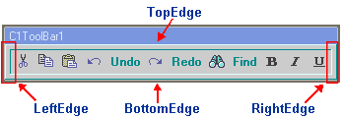

The TopEdge, LeftEdge, BottomEdge, and RightEdge properties are useful for applying borders to specific areas such as the top, bottom, left, or right edge of the C1ToolBar. These properties are set to True by default.

The following table illustrates each of the property settings for Style property. In addition to the various border styles shown below, the table also illustrates the Width, DarkColor, LeftEdge, RightEdge, BottomEdge, and TopEdge properties. The Width property is set to 5 pixels, DarkColor property is set to DarkTurquoise, LeftEdge property is set to PaleTurquoise, and
the LeftEdge, RightEdge, BottomEdge, and TopEdge are all set to True.

Property Setting | Image
Style.None | 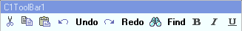
Style.Flat
Style.Groove
Style.Ridge
Style.Inset
Style.Outset
The following table illustrates the effect of the LeftEdge, RightEdge, BottomEdge, and TopEdge
when each one is disabled:

Property Setting | Image
BottomEdge.False | 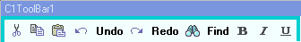
LeftEdge.False | 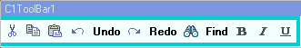

RightEdge.False
TopEdge.False | 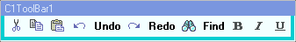
For more information about using these properties, see Modifying the Appearance of the Toolbar.

Mouse-Over Styles in Toolbar Buttons
You can apply mouse over techniques to the toolbar buttons to improve your toolbar interaction with users.

The C1ToolBar component has two special properties for applying mouse-over techniques.
The BackHiColor property gets the back color of the toolbar button when you hover your mouse over it and the ForeHiColor gets the fore color of the toolbar button when you hover your mouse over it.

For more information about using these properties, see Modifying the Appearance of the Toolbar.

Docking and Floating Toolbars
Toolbars can be docked to the top, left, right or bottom on the container that the
C1CommandDock has been assigned to.

Each C1ToolBar resides inside the docking area when it is docked. Toolbars can be moved to different docking areas by using a drag-and-drop operation, and they can also be resized.

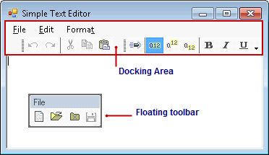

If you are creating a C1ToolBar programmatically and would like to use the C1CommandDock to enable docking and floating behavior you would add the toolbar to the C1CommandDock like the following:

To write code in Visual Basic

Visual Basic | Copy Code
Me.C1CommandDock = New C1.Win.C1Command.C1CommandDock() Me.C1CommandDock.Controls.Add(Me.C1ToolBar1) Me.Controls.Add(Me.C1CommandDock)

To write code in C#

C# | Copy Code
this.c1CommandDock = new C1.Win.C1Command.C1CommandDock(); this.c1CommandDock.Controls.Add(this.c1ToolBar1); this.Controls.Add(this.c1CommandDock);

Embedded Controls in Toolbars
The C1CommandControl lets you embed arbitrary controls to the toolbar.

Arbitrary controls such as a textbox can be embedded in a C1ToolBar through the use of the
C1CommandControl.

This can simply be done by dragging an arbitrary control on to the toolbar, adding a C1CommandControl command type through the designer, or adding a C1CommandControl command type programmatically.

For more information about how to embed an arbitrary control into the C1ToolBar object, see
Adding an Arbitrary Control to the Toolbar.

When an arbitrary control is dragged to the toolbar it automatically creates a new command type called C1CommandControl. The C1CommandControl includes a Control property which gets the arbitrary control attached to the command.

The following image shows a RadioButton, CheckBox, and a ComboBox control embedded into the C1ToolBar.

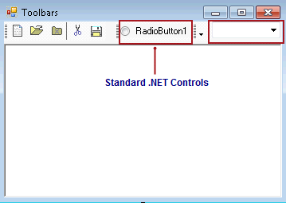

Run-Time Customization for Toolbars
C1ToolBars can be customizable at run time by setting the CustomizeButton property to True at design time.

Note: The toolbar needs to be placed inside a C1CommandDock before you set its

CustomizeButton property to True at design-time.

When the customization is enabled a drop-down arrow appears on the toolbar at design time.

The pop-up menu appears at run time when you click on the drop-down arrow.

The Customize toolbars menu operates as follows:

Add or Remove Buttons

Clicking on a command item from the menu removes the command button from the toolbar.

Reset

Clicking on the Reset menu item resets the toolbar back to its original setting.

Customize

Clicking on Customize menu item opens the Customize toolbars dialog box.

The Customize Dialog contains three tabs for modifying the C1ToolBar component:

  - Toolbars – This tab contains options for creating, renaming, deleting, and modifying the
C1ToolBar component.
  - Commands – This tab contains options for adding existing commands to the toolbars.
  - Options – This tab contains options for modifying the C1ToolBars general appearance properties such as its look and feel and its font and color.

On the bottom of each tab in the Customize toolbars dialog box, there is a Save, Restore, Reset, OK, and Cancel command button which can be used to save the updated settings of the toolbar, restore the update settings, reset the default settings, accept the new settings, and cancel the Customize toolbars respectively.

For the end-user customizations to be persisted in the application config file, command holder's Environment property must be added to dynamic properties.

Note: The user interface for dynamic properties has been removed from Visual Studio 2005. It still supports the dynamic properties. For more information about using the dynamic properties, please see the following topic in Microsoft Visual Studio 2005 documentation: Introduction to Dynamic Properties (Visual Studio).

To Save the Layout in the Application's .Config File:

- Click on the C1CommandHolder in the form's Component Tray.
- Expand the DynamicProperties node and then click on the ellipsis button next to the
Advanced property.
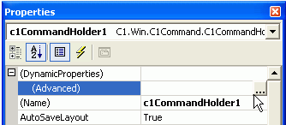

The Dynamic Properties dialog box appears.

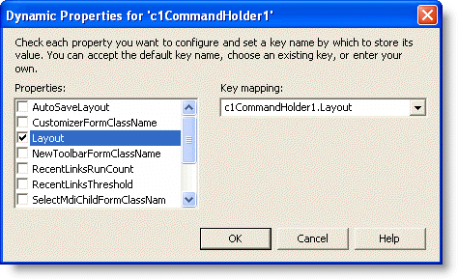
- Click the Layout check box and then click OK. This will make Layout saved in the application's .config file instead of in the form's code.

Note: When you run your program from the Visual Studio's designer, Visual Studio creates an app.config file in the project directory, and then on each run replaces the actual application's
.config file (located in the bin directory) with that app.config file's contents. As a result, if you

run the project in Visual Studio, change the toolbars layout, close it and then run it again, you won't see the last layout restored. This is not a bug, everything works fine when the application is not run from Visual Studio.

In addition to saving your toolbar layout using the form's dynamic properties you can also use your own scheme for saving and restoring the toolbars layout. For finer control, save and set the value of the Layout property in your code instead.

Toolbars

The Toolbars tab contains options for creating and manipulating toolbars.

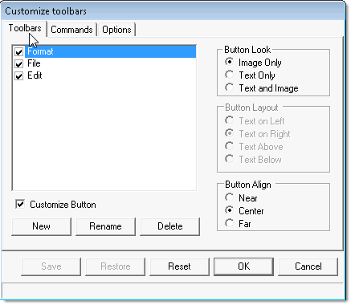

By default, the ButtonLook and the CustomizeButton properties are disabled.

The Button Layout properties are enabled when the ButtonLook property is set to Text and Image(the Text and Image radio button is selected). This is because the ButtonLayoutHorz property determines how the text is placed by the image (above, below, to the left, or to the right of the image).

The CustomizeButton is enabled when a new C1ToolBar is added to the dialog box.

Commands

The Commands tab contains two list boxes: Categories and Commands. The Categories list box contains the categories for all of the commands. The Commands list box contains all of the commands for each category.

Note: The Categories list box appears empty if the Category property is not set for the commands.

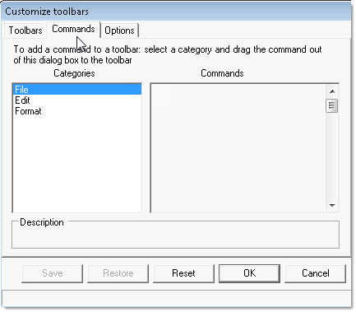

Commands can be easily added to the toolbars by doing either of the following:

  - Selecting a category from the Categories list box.
  - Selecting a command from the Commands list box and then dragging it to the desired toolbar.

The following image illustrates a command being dragged from the Commands list to the Format toolbar on the form at run time.

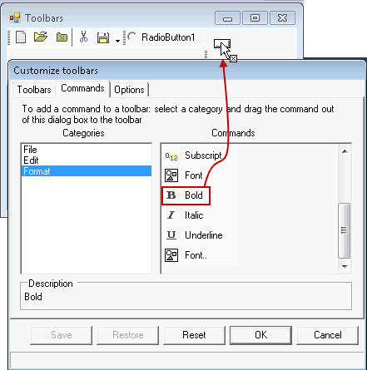

Options

The Options tab contains options for modifying C1ToolBar’s general appearance properties such as its look and feel and its colors and font.

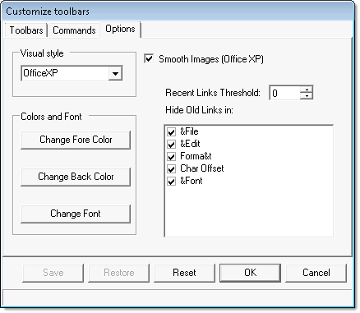

Wrapping Toolbar Buttons and Text
C1ToolBar provides wrapping ability for toolbar buttons as well as wrapping text in the toolbar buttons. The Wrap property wraps the toolbar to another line so all of its toolbar buttons appear. By default, this property is enabled.

The following image shows how the toolbar buttons appear when its Wrap property set to False.

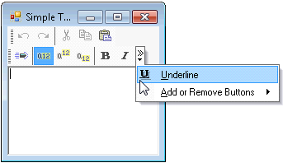

The following image shows how the toolbar buttons appear when its Wrap property set to True.

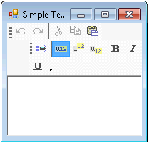

The following image shows how the toolbar buttons appear when its Wrap is set to True and its
WrapText properties is set to False.

The following image shows how the toolbar buttons appear when their Wrap and WrapText
properties are set to True.

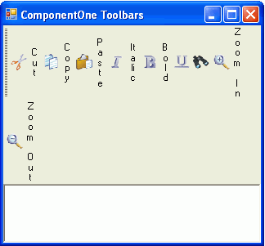

ToolTips in Toolbars
A ToolTip is used to display text when the mouse hovers over the control. C1ToolBar provides
a ShowToolTips property that displays the value of the Text property as a ToolTip for each toolbar button. This property is enabled by default.

Note: If you have the C1CommandLink.Text property set for the button, but not its C1Command.Text property the ToolTip will get its default C1Command.Text name. For example, if it’s the first button the toolTip and C1Command.Text name would be Button1.

If you would like to enter custom text for the ToolTip of each toolbar button you can through the ToolTipText property.

The following image depicts a toolbar that has its ShowToolTips property set to True.

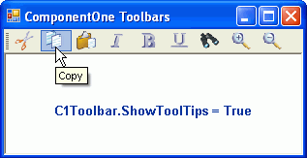

The following image shows a toolbar that has its ShowToolTips property set to True and custom text entered for fourth C1CommandLink's ToolTipText property.

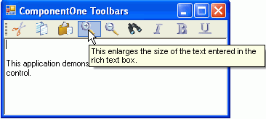

For more information about using ToolTips, see Displaying ToolTips for Menus and Toolbars.

Toolbar and Button Layout Behavior
C1ToolBars layout is very flexible. They can be horizontal or vertical as well as docked to specific areas of the form. The toolbar's Movable property is enabled by default. This allows the user to move the toolbar anywhere on the form. The default layout for a toolbar is horizontal. You can change the toolbar layout to vertical by setting the Horizontal to False.

Note: When you set the ToolBarStyle property to DropDownMenu, the menu behaves like a drop-down so the toolbar becomes stationary.

In addition to toolbar orientation, C1ToolBar also provides button alignment for vertical toolbars. You can align the image or text near, center, or far from the button through the ButtonAlign property.

The following table shows the values for the ButtonAlign property:

Property Setting | Image
ButtonAlign.Near | 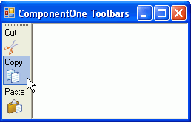
ButtonAlign.Center | 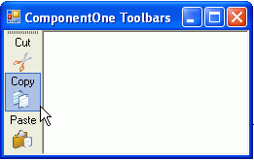
ButtonAlign.Far | 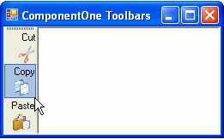
You can determine the relative position of text and images for toolbar buttons in horizontal and
vertical toolbars using the ButtonLayoutHorz and ButtonLayoutVert properties.
The ButtonLayoutHorz property gets the layout of the buttons when the toolbar is horizontal. This is the default orientation of the toolbar. The ButtonLayoutVert property gets the layout of the buttons when the toolbar is vertical. Setting the Horizontal property to False gets the vertical orientation for the toolbar.

Note: The default value for the ButtonLayoutHorz property is TextOnRight.

C1ToolBar provides several options for customizing the toolbar buttons for vertical and horizontal toolbars.

Property Setting | Image
ButtonLayoutHorz.TextOnRight (default) | 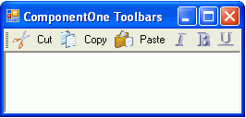
ButtonLayoutHorz.TextOnLeft | 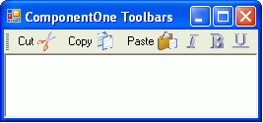
ButtonLayoutHorz.TextAbove | 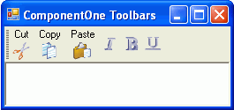
ButtonLayoutHorz.TextBelow | 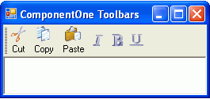
In addition to controlling the relative position of text and images for toolbar buttons you can also
set the ButtonLookHorz property to display text, images, or both for the horizontal toolbar and the ButtonLookVert property to display text, images, or both for the vertical toolbar.

Note: The Text, Image, and TextAndImage values for the ButtonLook property overrides the

values for the ButtonLookHorz and ButtonLookVert properties. The ButtonLook property should be set to default if you plan on setting values for the ButtonLookHorz or ButtonLookVert property.

The following table shows the values for the ButtonLayoutVert property:

Property Setting | Image
ButtonLayoutVert.TextOnRight | 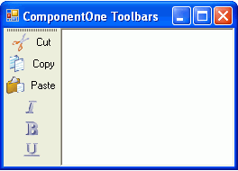
ButtonLayoutVert.TextOnLeft | 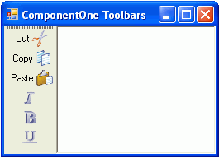
ButtonLayoutVert.TextAbove | 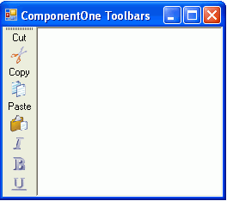

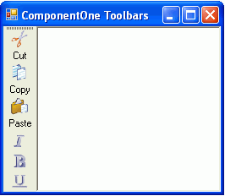 ButtonLayoutVert.TextBelow (default)

