Context Menu Tasks
This section shows how to perform specific context menu tasks.

See Also

Adding a C1ContextMenu to a Control

Retrieving the C1ContextMenu Control Attached to the C1TextBox Linking the C1Context Menu to a NotifyIcon Control
Adding a C1ContextMenu to a C1DockingTab

Adding a C1ContextMenu to a Control
You can add a C1ContextMenu to a control at design time or through code. Click on either of the following links to expand the steps for the designer or for the code.

To add a C1ContextMenu to a Control at design time

To create a context menu and associate it with a menu item, complete the following tasks:

Note: In this example, a C1ContextMenu is associated with a menu item.

- Place a C1MainMenu on the form, right-click New Command, and then select Edit from its context menu. The Link to Command designer appears.
- In the Link to Command designer, change the following command properties.
  - Text textbox to File
  - Name textbox to MenuFile
- Select ContextMenu from the Create a new command listbox. This will create a
command with a submenu which can be used as a context menu. Select OK, in the Link to Command dialog box. The new C1MainMenu, File will appear.
- Right-click on the New Command item in the File menu and select Edit from its context menu. Set the properties in the Link to Command designer to the following:
  - Text to New
  - Name to cmdFileNew
- Select C1Command from the Create a new command listbox.
- Click OK.
- Right-click the New menu, select Append Item from its context menu, and then set its properties in the Link to Command designer to the following:
  - Text to Open
  - Name to cmdFileOpen
- Select C1Command from the Create a new command listbox.
- Click OK.
- Select the Windows Form tab from the Toolbox and place the RichTextBox control onto your form using a drag-and-drop operation.

- Select the richTextBox1 control from the Properties drop-down list box then set its Dock
property to Fill.
- Select the MenuFile from the Properties drop-down list, then select the Category property and enter File in its box.
- Select richTextBox1 from the Properties drop-down list, then select the C1ContextMenu on C1CommandHolder property, and then select MenuFile.
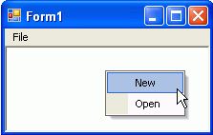
- Run the application and then right-click your mouse anywhere in the rich text box. The context menu for the File menu appears like the following image.

To add a C1ContextMenu to a control programmatically

To add a C1ContextMenu to a control, complete the following steps:

- Attach the C1.Win.C1Command to your reference project located in the solution explorer, and then add the C1.Win.C1Command namespace to your source file.
- Place the TextBox control onto your form using a drag-and-drop operation.
- To create a C1CommandHolder so it will hold the command, double-click on the form control to create a Form_Load event handler and add the following code:

Note: Use the try and catch method if you want to create more than one command holder for a form. This will catch and ignore the exception when the second attempt to create another commandholder fails.

- To write code in Visual Basic

Visual Basic | Copy Code
Dim ch As C1.Win.C1Command.C1CommandHolder ch = C1CommandHolder.CreateCommandHolder(Me)

- To write code in C#

C# Copy Code

C1CommandHolder ch = C1CommandHolder.CreateCommandHolder(this);

- Create and set up a copy command, then use the Click event to copy the command when you click on the menu item. Also set up the query handler for the commands so their command is kept up to date automatically by c1command. Add the following code within the form load event handler:

To write code in Visual Basic

Visual Basic | Copy Code
'Create and set up the Copy command
Dim cmdCopy As C1Command = ch.CreateCommand() cmdCopy.Text = "&Copy"
AddHandler cmdCopy.Click, AddressOf clickCopy
AddHandler cmdCopy.CommandStateQuery, AddressOf queryCopy

To write code in C#

C# | Copy Code
// Create and set up the Copy command C1Command cmdCopy = ch.CreateCommand(); cmdCopy.Text = "&Copy";
cmdCopy.Click += new C1.Win.C1Command.ClickEventHandler(clickCopy); cmdCopy.CommandStateQuery += new C1.Win.C1Command.CommandStateQueryEventHandler(queryCopy);

- Create a context menu to hold the copy command, then assign the context menu to the text box control. In order to create a context menu you must create a command in the C1CommandHolder and assign it to the context menu. Use the C1CommandHolder.CreateCommand and C1CommandHolder.SetC1ContextMenu methods from the C1CommandHolder class. Add the following code within the Form_Load event handler:

To write code in Visual Basic

Visual Basic | Copy Code
Dim cm As C1ContextMenu = Ctype(ch.CreateCommand(GetType(C1ContextMenu)), C1ContextMenu)
'Fill it with the links to the commands cm.CommandLinks.Add(New C1CommandLink (cmdCopy)) ch.SetC1ContextMenu(TextBox1, cm)

To write code in C#

C# | Copy Code
C1ContextMenu cm = ch.CreateCommand(typeof(C1ContextMenu)) as C1ContextMenu;
// Fill it with the links to the commands cm.CommandLinks.Add(new C1CommandLink(cmdCopy)); ch.SetC1ContextMenu(textBox1, cm);

- Invoke the clickCopy method to handle the copy command action. Use the queryCopy method to provide the current state of the copy command. When you click the copy command from the context menu, the current text will be copied into the textbox. You can achieve this by using the following code:

To write code in Visual Basic

Visual Basic | Copy Code
Private Sub clickCopy(ByVal sender As Object, ByVal e As C1.Win.C1Command.ClickEventArgs)
Me.textBox1.Copy()
End Sub

'provides the current state of the copy command

Private Sub queryCopy(ByVal sender As Object, ByVal e As C1.Win.C1Command.CommandStateQueryEventArgs)
e.Enabled = Me.textBox1.SelectionLength > 0
End Sub

To write code in C#

C# | Copy Code
private void clickCopy(object sender, C1.Win.C1Command.ClickEventArgs e)
{
this.textBox1.Copy();
}

//provides the current state of the copy command

private void queryCopy(object sender, C1.Win.C1Command.CommandStateQueryEventArgs e)
{
e.Enabled = this.textBox1.SelectionLength > 0;
}

- Save and run the application. Enter some text into the text box, then right-click the text to make the context menu appear. The following image shows how the context menu appears next to the text box control at run time:
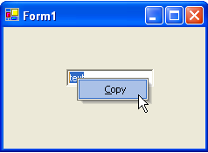

Retrieving the C1ContextMenu Control Attached to the C1TextBox
Use the GetC1ContextMenu method of C1CommandHolder class to determine which C1ContextMenu is attached to a control. The GetC1ContextMenu method returns the context menu attached to a specific control.

To retrieve the name of the C1ContextMenu control attached to the C1TextBox1, use the following code:

To write code in Visual Basic

Visual Basic | Copy Code
'retrieves the contextmenu attached to the C1TextBox control Dim contextMenu As C1.Win.C1Command.C1ContextMenu contextMenu = C1CommandHolder1.GetC1ContextMenu(C1TextBox1) MessageBox.Show(ContextMenu.Name)

To write code in C#

C# | Copy Code
//retrieves the contextmenu attached to the C1TextBox control
C1.Win.C1Command.C1ContextMenu contextMenu;
contextMenu = C1CommandHolder1.GetC1ContextMenu(C1TextBox1); MessageBox.Show(ContextMenu.Name);

Linking the C1Context Menu to a NotifyIcon Control
C1ContextMenu supports linking to the standard NotifyIcon Control.

To link a C1ContextMenu to a NotifyIcon Control at design time, follow these steps:

  - Double-click on the C1ContextMenu control to add it to the component tray. This will also add a C1ComponentHolder control to the component tray.
  - Right-click on the C1ContextMenu control and select Edit from its context menu. A New Command item will appear on the form.
  - Right-click the New Command item and select Edit from its context menu to open the
Link to Command designer.
  - Change the following command properties in the Link to Command designer:
    - Change the Name textbox text to MenuFile.
    - Change the Text textbox text to Menu.
  - Select C1CommandMenu from the Create a new command listbox.
  - Select OK in the Link to Command designer and the new menu will appear on the form.
  - Right-click the New Command item in the Menu and select Edit from its context menu to open the Link to Command designer.
  - Change the following properties in the Link to Command designer:
    - Change the Name textbox text to OpenFile.
    - Change the Text textbox tect to Open.
  - Select View | Properties from the Visual Studio toolbar. Select C1ContextMenu1 from the
drop-down list at the top of the Properties window.
  - Set the C1ContextMenu property to C1ContextMenu1.

  - Double-click the NotifyIcon component in the Windows Forms Toolbox to add the component to the component tray.
  - Right-click on the component and select Choose an icon from its context menu. Choose an icon to represent the component at run time.
  - Select View | Properties from the Visual Studio toolbar. Select notifyicon1 from the drop- down list at the top of the Properties window.
  - Set the C1ContextMenu property to C1ContextMenu1 to link the two components.
  - Run your application. The icon you chose to represent the NotifyIcon component will appear in the System Tray. Note that when you right-click the icon, the context menu opens.

This topic illustrates

Linking a C1ContextMenu to a standard Windows Forms control.

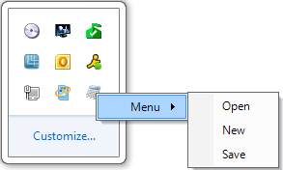

Adding a C1ContextMenu to a C1DockingTab
Complete the following steps to add a C1ContextMenu control to a C1DockingTab control.

- Locate the C1ContextMenu control in your Toolbox and double-click the control to add it to your Component Tray. A C1CommandHolder will also be added to the Component Tray.
- Use the C1ContextMenu smart tag to open the C1ContextMenu Tasks Menu. Select Add Item from the Tasks Menu to add an item to the C1ContextMenu. Add two more items to
the menu.
- Place a C1DockingTab control on the form and open the C1DockingTab Context Menu.
Select Add Page from the context menu. Add several pages to the C1DockingTab.
Select the C1DockingTab control on your form to view the properties. Click the Events button and locate the MouseClick event. Insert c1DockingTab1_MouseClick to create the MouseClick event.
- Right-click on the form and select View Code from the list. Insert the following code after the InitializeComponent() method:

To write code in Visual Basic

Visual Basic Copy Code

Private Sub c1DockingTab1_MouseClick(ByVal sender As Object, ByVal e As MouseEventArgs)
If (e.Button = System.Windows.Forms.MouseButtons.Left) Then If (e.X > Me.c1DockingTabPage1.Location.X) Then
c1ContextMenu1.ShowContextMenu(Me.c1DockingTab1, New Point(e.X,

e.Y))

Else

Me.c1DockingTab1.ContextMenu = Nothing

End If End If
End Sub

To write code in C#

C# | Copy Code
private void c1DockingTab1_MouseClick(object sender, MouseEventArgs e)
{
if (e.Button == System.Windows.Forms.MouseButtons.Left)
{
if (e.X > this.c1DockingTabPage1.Location.X)
{
c1ContextMenu1.ShowContextMenu(this.c1DockingTab1, new Point(e.X, e.Y));
}
else
this.c1DockingTab1.ContextMenu = null;
}
}

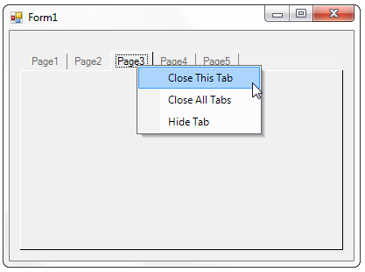
- Press F5 to run your application. Note that when you click on a tab, the C1ContextMenu
opens:

DockingTab Tasks
This section shows how to perform specific docking tab tasks.

See Also

Adding a Scrollbar to a C1DockingTab Closing a C1DockingTabPage
Determining if the C1DockingTab is Floating Displaying Multiple Tab Rows
Displaying the Same Set of Controls on each C1DockingTabPage

Enabling DockingTab Docking and Floating Enabling or Disabling Focus Cues
Loading and Saving the Layout of the C1DockingTab Moving Tab Pages at Run Time
Pinning the C1DockingTab

Preventing the Tabs from Receiving Focus on Mouse Click Restricting the Usage of Specific Tabs

Adding a Scrollbar to a C1DockingTab
To add a scrollbar to a C1DockingTab, complete the following steps:

Note: The C1DockingTab does not have its own scrollbar.

- Place a C1CommandDock control on the form, and then set its Dock property to Fill.
- Add a C1DockingTab inside the C1CommandDock.
- Add a Panel control inside the C1DockingTabPage, and then set the Panel's Dock property to Fill.
- Place a few Windows Form controls inside Panel1 of the C1DockingTabPage.

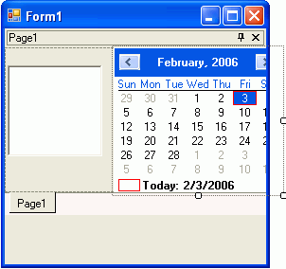
- Set Panel1's AutoScroll property to True.

The scrollbars appear for the C1DockingTab.

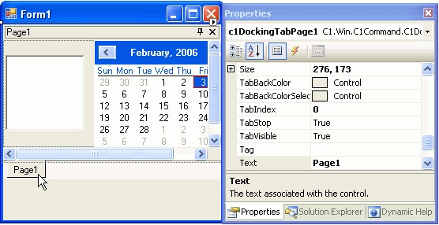

Closing a C1DockingTabPage
You can close the C1DockingTabPage in code by using the TabVisible property of the
C1DockingTabPage. The following code can be used for closing the first page:

To write code in Visual Basic

Visual Basic | Copy Code
Me.C1DockingTab1.TabPages(0).TabVisible = False

To write code in C#

C# | Copy Code
this.C1DockingTab1.TabPages(0).TabVisible = False;

Determining if the C1DockingTab is Floating
To find out if the docking tab is currently Floating, use the Floating (run time) only property of the
C1DockingTab. This syntax of the property is as following:

To write code in Visual Basic

Visual Basic | Copy Code
Public Floating As Boolean

To write code in C#

C# | Copy Code
Public bool Floating {get;}

Displaying Multiple Tab Rows
To display more than one row of tab in a C1DockingTab, set the MultiLine property of the
C1DockingTab class to True. To do this, complete the following tasks:

  - Set the MultiLine property of the C1DockingTab class to True.
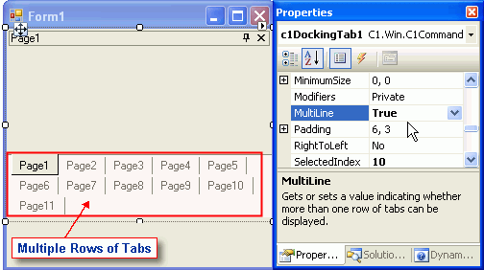
  - Right-click on Page1 of the C1DockingTabPage and select Add Page from its context menu. Add several pages to the C1DockingTab. The tabs continue to another row.

Displaying the Same Set of Controls on each C1DockingTabPage
To display the first set of controls on C1DockingTabPage for the rest of the C1DockingTabPages without duplicating them, perform the following steps:

- Add a panel to the first C1DockingTabPage and then set its Dock property to Fill so it spans the whole C1DockingTabPage.
- Add the controls on the panel.

- In the SelectedIndexChanging event handler move the panel from the previous docking tab page to the new one.

To write code in Visual Basic

Visual Basic | Copy Code
Me.dockingTab.SelectedTab.Controls.Add (myPanel)

To write code in C#

C# | Copy Code
this.dockingTab.SelectedTab.Controls.Add (myPanel);

Enabling DockingTab Docking and Floating
To add a C1DockingTab to your form, complete the following basic operations:

- Place the C1CommandDock control onto your form using a drag-and-drop operation.
- The C1CommandDock will dock to the left side of the form. Select the drop-down arrow in the C1CommandDock.Dock property and click the top rectangle. This will dock the C1CommandDock control to the top of the form.
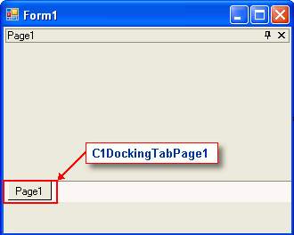
- Place the C1DockingTab control inside the C1CommandDock control using a drag-and- drop operation. It will appear like this on your form:

- Build and run the application. Select Page1 with your mouse and drag it downward. Your docking tab at run time should look like the following docking tab:
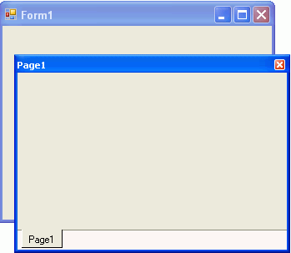

Note: You can use the C1CommandDock property FloatHide to control how the C1DockingTabPage behaves at run-time. This property allows you to choose to keep focus on the tab pages when the application loses focus. There are three possible settings for C1CommandDock.FloatHide: Default, Never, or FocusLost.

Enabling or Disabling Focus Cues
You can easily enable or disable focus cues for the C1DockingTab using the C1DockingTab.TabsShowFocusCues property. By default, this property is set to true. This topic will cover setting this property to false in design time and in code.

In Design Time

In the Properties window, set the C1DockingTab.TabsShowFocusCues to false.

In Code

To write code in Visual Basic

Visual Basic | Copy Code

c1DockingTab1.TabsShowFocusCues = false

To write code in C#

C# | Copy Code
c1DockingTab1.TabsShowFocusCues = false;

Loading and Saving the Layout of the C1DockingTab
You can save and load the layout of the C1DockingTab by using the SaveLayout and RestoreLayout
methods. The syntax for the methods is as follows:

To write code in Visual Basic

Visual Basic | Copy Code
'Saves the current layout of the tabs on the form to the specified file.
Shared Sub SaveLayout(form As Form, filename As String)

'Restores the previously saved layout of the tabs on the form from the specified file
Sub RestoreLayout(form As Form, filename As String)

To write code in C#

C# | Copy Code
//Saves the current layout of the tabs on the form to the specified file.
static void SaveLayout(Form form, string filename);

//Restores the previously saved layout of the tabs on the form from the specified file
Static void RestoreLayout(Form form, string filename);
The following code is an example of how these methods can be applied:

To write code in Visual Basic

Visual Basic | Copy Code
//Saves the current layout of the tabs on the form to the specified file.
C1DockingTab.SaveLayout(myForm, "myLayoutFile.xml")

'Restores the previously saved layout of the tabs on the form from the specified file
C1DockingTab.RestoreLayout(myForm, "myLayoutFile.xml")

To write code in C#

C# | Copy Code
//Saves the current layout of the tabs on the form to the specified file.
C1DockingTab.SaveLayout (myForm, "myLayoutFile.xml");

//Restores the previously saved layout of the tabs on the form from the specified file
C1DockingTab.RestoreLayout(myForm, "myLayoutFile.xml");

Moving Tab Pages at Run Time
To move tabs in different positions, use the CanMoveTabs property. In the properties toolbox set the CanMoveTabs to True.

Pinning the C1DockingTab
To pin the C1DockingTab programmatically, set the AutoHiding property of the C1DockingTab to
False. Use the following code:

To write code in Visual Basic

Visual Basic | Copy Code
Me.C1DockingTab1.AutoHiding = False

To write code in C#

C# | Copy Code
this.C1DockingTab1.AutoHiding = False;
 | Note: To correctly pin and unpin the C1DockingTab, it must be placed in a C1CommandDock control.

Preventing the Tabs from Receiving Focus on Mouse Click
To prevent the tabs from receiving focus, use the TabsCanFocus property. Setting this property to
False will prevent the tabs from receiving focus on Mouse click.

Restricting the Usage of Specific Tabs
You can add a handler to the SelectedIndexChanging event to test whether the index of the page is the page that you don't want the user to switch to. If so, e.Cancel would be set to True. For example, the following code shows how to add a handler to the SelectedIndexChanging event:

To write code in Visual Basic

Visual Basic | Copy Code
Private Sub c1DockingTab1_SelectedIndexChanging(sender As Object, e As C1.Win.C1Command.SelectedIndexChangingEventArgs)
If e.NewIndex = 1 And e.CanCancel Then e.Cancel = True
End If End Sub

To write code in C#

C# | Copy Code
private void c1DockingTab1_SelectedIndexChanging(object sender, C1.Win.C1Command.SelectedIndexChangingEventArgs e)
{
if(e.NewIndex == 1 && e.CanCancel) e.Cancel = true;

}

