Design-Time Support
C1Command provides visual editing to make it easier to create menus, toolbars, outbars, and docking tabs with the Microsoft Visual Studio .NET look and feel.

You can make changes to the C1Command controls by using one or more of the following visual editors:
In-Place Editing
You can quickly edit menu and toolbar items' text using the in-place editing feature. For more information about using the in-place editing feature, see In-Place Text Editing.

Invoking the Smart Tags

You can easily set common properties for the C1Command controls using its smart tags. For more information about the smart tags in C1Command, see C1Command Smart Tags.

Invoking the Context Menus

You can easily configure any of the C1Command components at design time by using its associated context menu. For more information on C1Command context menus, see the C1Command Context Menus.
Invoking the C1Command Editor

You can easily edit C1CommandLinks at design-time through its Edit designer.

Design Time Editors

C1Command provides seven collection editors: C1Command Collection Editor, C1CommandLink Collection Editor, C1DockingTabPage Collection Editor, C1NavBarButton Collection Editor, C1OutPage Collection Editor, C1TopicPage Collection Editor, and C1TopicLink Collection Editor. The main part for each of the editor's application consists of a windows form which conveniently allows the user to edit
the C1MainMenu, C1ToolBar, C1DockingTab, C1NavBar, C1OutBar, or C1TopicBar controls.

Showing the C1Command Control's Properties

You can access the properties for any of C1Commands components simply by right-clicking on the control and selecting Properties or by selecting the class from the drop-down box of the Properties window.

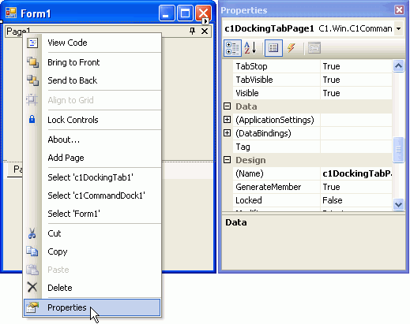

The following section details each type of support available in C1Command.

See Also

In-Place Text Editing C1Command Smart Tags C1Command Context Menus Link to Command Designer C1Command Collection Editor C1Command Smart Designer

In-Place Text Editing
Rather than going through the menu's or toolbar's Edit designer or Properties window to edit their text you can simply edit their text directly on their control.

To use this feature, perform the following:

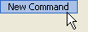
- Select the menu item or toolbar item so it's highlighted.

- Press ENTER.
menu item or toolbar item's text is ready to be edited.
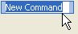
- Press ENTER again to accept the change or press ESC to cancel the change.

C1Command Smart Tags
In Visual Studio 2005, each component/command in C1Command includes a smart tag. A smart tag represents a short-cut tasks menu that provides the most commonly used properties in each component/command.

The following section introduces each smart tag for C1Commands components/commands.

See Also

C1CommandHolder Smart Tag C1MainMenu Smart Tag C1ContextMenu Smart Tag C1NavBar Smart Tag C1NavBar Panel Smart Tag C1ToolBar Smart Tag C1TopicBar Smart Tag C1DockingTab Smart Tag C1DockingTabPage Smart Tag C1OutBar Smart Tag C1OutPage Smart Tag

C1CommandHolder Smart Tag
The C1CommandHolder component provides quick and easy access to common properties through its smart tag.

To access the C1CommandHolder Tasks menu, click on the smart tag () in the upper right corner of the C1CommandHolder control. This will open the C1CommandHolder Tasks menu.

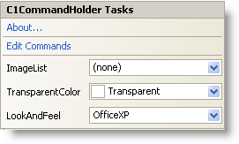

The C1CommandHolder Tasks menu operates as follows:

VisualStyle

Selecting the VisualStyle drop-down box opens a list box with several items to choose from (Custom, System, Office2010Blue, Office2010Black, Office2010Silver, Office2007Blue, Office2007Black, Office2007Silver, Office2003Blue, Office2003Olive, Office2003Silver, OfficeXP, Classic, and WindowsXP) to set the look and feel style of the commands. Note that the C1CommandHolder.VisualStyle property and VisualStyle enumeration supersede the LookAndFeel property and LookAndFeelEnum enumeration, which are now obsolete.

ImageList

Selecting the ImageList drop-down button opens a list box that contains an imagelist item if an ImageList component is present.

TransparentColor

Selecting the TransparentColor drop-down box opens the list box of Custom, Web, and System colors to choose from.

Edit Commands

Clicking Edit Commands opens the C1Command Collection Editor. For more information on how to use the C1Command Collection Editor, see C1Command Collection Editor.

About

Clicking on the About item displays the About ComponentOne Command dialog box, which is helpful in finding the version number of C1Command and online resources.

C1MainMenu Smart Tag
The C1MainMenu control provides quick and easy access to common properties through its smart tag.

To access the C1MainMenu Tasks menu, click on the smart tag () in the upper right corner of the C1MainMenu control. This will open the C1MainMenu Tasks menu.

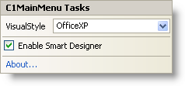

The C1MainMenu Tasks menu operates as follows:

VisualStyle

Selecting the VisualStyle drop-down box opens a list box with several items to choose from (Custom, System, Office2010Blue, Office2010Black, Office2010Silver, Office2007Blue, Office2007Black, Office2007Silver, Office2003Blue, Office2003Olive, Office2003Silver, OfficeXP, Classic, and WindowsXP) to set the look and feel style of the C1MainMenu control. Note that the C1MainMenu.VisualStyle property and VisualStyle enumeration supersede the LookAndFeel property and LookAndFeelEnum enumeration, which are now obsolete.

Enable Smart Designer

Clicking on the Smart Designer check box enables the Smart Designer of the C1MainMenu control.

About

Clicking on the About item displays the About ComponentOne Command dialog box, which is helpful in finding the version number of C1Command and online resources.

C1ContextMenu Smart Tag
The C1ContextMenu component provides quick and easy access to add menu items and edit them through its Link to Command designer. This is available through its smart tag.

To access the C1ContextMenu Tasks menu, click on the smart tag () in the upper right corner of the C1ContextMenu component. This will open the C1ContextMenu Tasks menu.

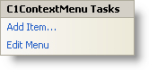

The C1ContextMenu Tasks menu operates as follows:

Add Item

Clicking on the Add Item adds a new command after the current command and opens the Link to Command designer.

For more information how to use the Link to Command designer, see Link to Command designer.

Edit Menu

Clicking on the Edit Menu item displays the command items in the context menu that is attached to a specific control such as C1MainMenu or C1ToolBar.

C1NavBar Smart Tag
The C1NavBar control provides quick and easy access to common properties and its most common editing actions such as adding buttons through its smart tag.

To access the C1NavBar Tasks menu, click on the smart tag () in the upper right corner of the
C1NavBar control. This will open the C1NavBar Tasks menu.

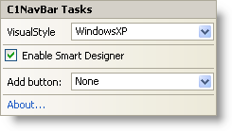

The C1NavBar Tasks menu operates as follows:

VisualStyle

Selecting the VisualStyle drop-down box opens a list box with several items to choose from (Custom, System, Office2010Blue, Office2010Black, Office2010Silver, Office2007Blue, Office2007Black, Office2007Silver, Office2003Blue, Office2003Olive, Office2003Silver, OfficeXP, Classic, and WindowsXP) to set the look and feel style of the C1NavBar control. Note

that the C1NavBar.VisualStyle property and VisualStyle enumeration supersede the LookAndFeel
property and LookAndFeelEnum enumeration, which are now obsolete.

Enable Smart Designer

Clicking on the Enable Smart Designer check box enables the Smart Designer for the C1NavBar
control.

Add button

Clicking on the Add button drop-down box opens a list box of pre-defined buttons to choose from such as Custom, Mail, Calendar, Contacts, Tasks, Notes, Folder, Shortcut, or Journal.

About

Clicking on the About item displays the About ComponentOne Command dialog box, which is helpful in finding the version number of C1Command and online resources.

C1NavBar Panel Smart Tag
The C1NavBarPanel Tasks menu makes it simple to change the VisualStyle and add section headers, horizontal rules, and docked panels.

To access the C1NavBarPanel Tasks menu, click on the smart tag () in the upper right corner of the C1NavBarPanel. This will open the C1NavBarPanel Tasks menu.

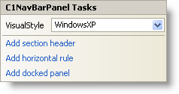

The C1NavBarPanel Tasks menu operates as follows:

VisualStyle

Selecting the VisualStyle drop-down box opens a list box with several items to choose from (Custom, System, Office2010Blue, Office2010Black, Office2010Silver, Office2007Blue, Office2007Black, Office2007Silver, Office2003Blue, Office2003Olive, Office2003Silver, OfficeXP, Classic, and WindowsXP) to set the look and feel style of the section headers, horizontal rules, and docked panels. Note that the C1NavBar.VisualStyle property and VisualStyle enumeration supersede the LookAndFeel property and LookAndFeelEnum enumeration, which are now obsolete.

Add Section Header

Clicking on the Add Section Header item adds a section header to the panel area of the selected button.

Add Horizontal Rule

Clicking on the Add Horizontal Rule item adds a horizontal line across the panel area of the selected button.

Add Docked Panel

Clicking on the Add Docked Panel item enables a dockable panel area of the selected button.

C1ToolBar Smart Tag
The C1ToolBar component provides quick and easy access to its most common properties.

To access the C1ToolBar Tasks menu, click on the smart tag () in the upper right corner of the
C1ToolBar control. This will open the C1ToolBar Tasks menu.

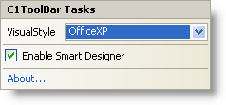

The C1ToolBar Tasks menu operates as follows:

VisualStyle

Selecting the VisualStyle drop-down box opens a list box with several items to choose from (Custom, System, Office2010Blue, Office2010Black, Office2010Silver, Office2007Blue, Office2007Black, Office2007Silver, Office2003Blue, Office2003Olive, Office2003Silver, OfficeXP, Classic, and WindowsXP) to set the style of the C1ToolBar. Note that the C1ToolBar.VisualStyle property and VisualStyle enumeration supersede the LookAndFeel property and LookAndFeelEnum enumeration, which are now obsolete.

Enable Smart Designer

Selecting the Enable Smart Designer check box enables the Smart Designer for the C1ToolBar
control.

About

Clicking on the About item displays the About ComponentOne Command dialog box, which is helpful in finding the version number of C1Command and online resources.

C1TopicBar Smart Tag
The C1TopicBar component provides quick and easy access to its C1TopicPage Collection Editor
and its most common editing actions such as adding topic pages through its smart tag.

To access the C1TopicBar Tasks menu, click on the smart tag () in the upper right corner of the C1TopicBar control. This will open the C1TopicBar Tasks menu.

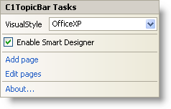

The C1TopicBar Tasks menu operates as follows:

VisualStyle

Selecting the VisualStyle drop-down box opens a list box with several items to choose from (Custom, System, Office2010Blue, Office2010Black, Office2010Silver, Office2007Blue, Office2007Black, Office2007Silver, Office2003Blue, Office2003Olive, Office2003Silver,
OfficeXP, Classic, and WindowsXP) to set the style of the C1TopicBar. Note that
the C1TopicBar.VisualStyle property and VisualStyle enumeration supersede the LookAndFeel
property and LookAndFeelEnum enumeration, which are now obsolete.

Enable Smart Designer

Clicking on the Enable Smart Designer check box enables the Smart Designer for the C1TopicBar
control.

Add Page

Clicking on the Add Page item, adds a new page below the current page in the C1TopicBar.

Edit Pages

Clicking on the Edit Pages item, opens the C1TopicPage Collection Editor. For additional information on the C1TopicPage Collection Editor, see C1TopicPage Collection Editor.

About

Clicking on the About item displays the About ComponentOne Command dialog box, which is helpful in finding the version number of C1Command and online resources.

C1DockingTab Smart Tag
The C1DockingTab control provides quick and easy access to its C1DockingTabPages Collection Editor and its most common editing actions such as adding new tab pages through its smart tag.

To access the C1DockingTab Tasks menu, click on the smart tag () in the upper right corner of the C1DockingTab control. This will open the C1DockingTab Tasks menu.

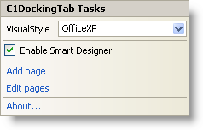

The C1DockingTab Tasks menu operates as follows:

VisualStyle

Selecting the VisualStyle drop-down box opens a list box with several items to choose from (Custom, System, Office2010Blue, Office2010Black, Office2010Silver, Office2007Blue, Office2007Black, Office2007Silver, Office2003Blue, Office2003Olive, Office2003Silver, OfficeXP, Classic, and WindowsXP) to set the style of the tabs. Note that the C1DockingTab.VisualStyle property and VisualStyle enumeration supersede the LookAndFeel property and LookAndFeelEnum enumeration, which are now obsolete.

Enable Smart Designer

Selecting the Enable Smart Designer check box enables the Smart Designer of the C1DockingTab control. The default value is True (checked). For more information about the Smart Designer's elements see, C1Command Smart Designer.

Add page

Clicking Add page adds a new C1DockingTabPage. C1DockingTabPage has a smart tag as well. For more information about C1DockingTabPage Tasks menu, see C1DockingTabPage smart tag.

Edit pages

Selecting Edit pages opens the C1DockingTabPage Collection Editor.

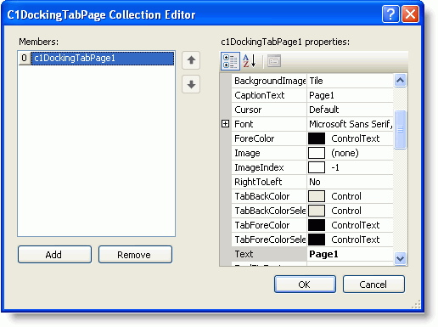

For more information on how to use the C1DockingTabPage Collection Editor, see
C1DockingTabPage Collection Editor.

About

Clicking on the About item displays the About ComponentOne Command dialog box, which is helpful in finding the version number of C1Command and online resources.

C1DockingTabPage Smart Tag
The C1DockingTabPage control makes it simple to change the VisualStyle and add new tab pages through its smart tag.

To access the C1DockingTabPage Tasks menu, click on the smart tag () in the upper right corner of the C1DockingTabPage. This will open the C1DockingTabPage Tasks menu.

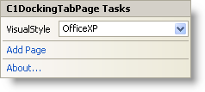

The C1DockingTabPage Tasks menu operates as follows:

VisualStyle

Selecting the VisualStyle drop-down box opens a list box with several items to choose from (Custom, System, Office2010Blue, Office2010Black, Office2010Silver, Office2007Blue, Office2007Black, Office2007Silver, Office2003Blue, Office2003Olive, Office2003Silver, OfficeXP, Classic, and WindowsXP) to set the style of the tab. Note that the C1DockingTab.VisualStyle property and VisualStyle enumeration supersede the LookAndFeel property and LookAndFeelEnum enumeration, which are now obsolete.

Add Page

Clicking Add Page adds a new C1DockingTabPage.

About

Clicking on the About item displays the About ComponentOne Command dialog box, which is helpful in finding the version number of C1Command and online resources.

C1OutBar Smart Tag
The C1OutBar control provides quick and easy access to its C1OutPage Collection Editor and its most common editing actions such as adding a blank page or a page with a toolbar, through its smart tag.

To access the C1OutBar Tasks menu, click on the smart tag () in the upper right corner of the
C1OutBar control. This will open the C1OutBar Tasks menu.

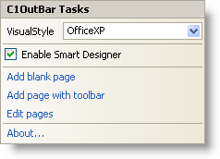

The C1OutBar Tasks menu operates as follows:

VisualStyle

Selecting the VisualStyle drop-down box opens a list box with several items to choose from (Custom, System, Office2010Blue, Office2010Black, Office2010Silver, Office2007Blue, Office2007Black, Office2007Silver, Office2003Blue, Office2003Olive, Office2003Silver, OfficeXP, Classic, and WindowsXP) to set the style of the C1OutBar control. Note that the VisualStyle property and VisualStyle enumeration supersede the LookAndFeel property and LookAndFeelEnum enumeration, which are now obsolete.

Enable Smart Designer

Selecting the Enable Smart Designer check box enables the Smart Designer of the C1OutBar control. The default value is True (checked). For more information about the Smart Designer's elements see, C1Command Smart Designer.

Add blank page

Clicking Add blank page adds a new C1OutPage below the current C1OutPage. Clicking inside the new C1OutPage exposes the smart tag anchor for the C1OutPage Tasks menu.

Add page with toolbar

Clicking Add page with toolbar adds a new C1OutPage which contains a C1ToolBar. A C1OutPageTasks menu appears for the newly added C1OutPage. Clicking inside the new page exposes the smart tag anchor for the C1ToolBar Tasks menu.

For more information on how to use the C1ToolBar Tasks menu, see C1ToolBar Smart Tag.

Edit pages

Selecting Edit pages opens the C1OutPage Collection Editor.

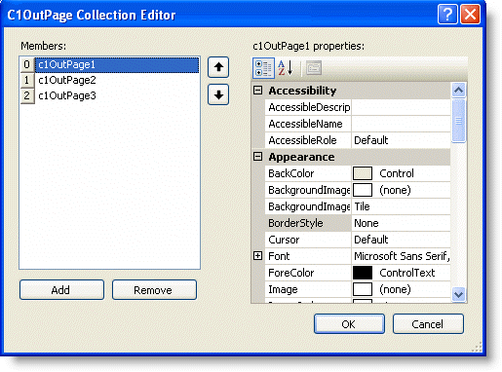For more information on how to use the C1OutPage Collection Editor, see C1OutPage Collection Editor.

About

Clicking on the About item displays the About ComponentOne Command dialog box, which is helpful in finding the version number of C1Command and online resources.

C1OutPage Smart Tag
The C1OutPage control provides quick and easy access to its C1OutPage Collection Editor and its most common editing actions such as adding a new blank page or a new page with a toolbar with only one click through its smart tag.

To access the C1OutPage Tasks menu, select the C1OutPage and click on the smart tag () in the upper right corner of the C1OutPage. This will open the C1OutPage Tasks menu.

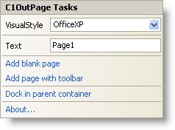

The C1OutPage Tasks menu operates as follows:

VisualStyle

Selecting the VisualStyle drop-down box opens a list box with several items to choose from (Custom, System, Office2010Blue, Office2010Black, Office2010Silver, Office2007Blue, Office2007Black, Office2007Silver, Office2003Blue, Office2003Olive, Office2003Silver, OfficeXP, Classic, and WindowsXP) to set the style of the C1OutPage control. Note that the C1OutBar.VisualStyle property and VisualStyle enumeration supersede the LookAndFeel property and LookAndFeelEnum enumeration, which are now obsolete.

Text

Selecting the Text box and entering a name gets the text for the C1OutPage.

Add blank page

Clicking Add blank page adds a new empty C1OutPage (without a C1ToolBar inside it) below the current C1OutPage.

Add page with toolbar

Clicking Add page with toolbar adds a new C1OutPage below the current C1OutPage. It also adds a new C1ToolBarinside it.

Dock in parent container

Clicking Dock in parent container docks the C1OutPage inside its parent container.

About

Clicking on the About item displays the About ComponentOne Command dialog box, which is helpful in finding the version number of C1Command and online resources.

C1Command Context Menus
Each of C1Commands components provides a context menu for additional functionality to use at design time.

Command Links context menu

Right-click on the command link item for a menu item or toolbar button to open the following context menu.

Note: The only difference between the Command Links context menu for menus and the one for toolbar is the Menu Properties/Toolbar Properties command.

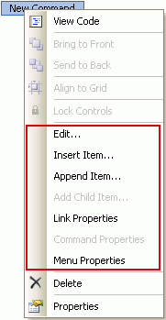

The following table provides a brief description of the custom items added by C1MainMenu and
C1ToolBar controls to their context menus:

Custom Items | Description
Edit | Brings up the Link to Command designer for the currently selected command link. You can edit the currently linked command, or link to another (new or existing) command. This item is disabled when there is no currently selected command link.
Insert Item | Inserts a new command link before the current one, and opens the Link to Command designer. This item is disabled when there is no currently selected command link.
Append Item | Adds a new command link after the last one in the current menu or toolbar, and brings up the command edit designer for the new link.

Add Child Item | Adds a new command link to the menu (C1CommandMenu or C1ContextMenu) linked by the currently selected command link and it opens the Link to Command designer. This item is disabled unless the current command link is linked to a C1CommandMenuor C1ContextMenu type command.
Link Properties | Selects the command link and shows its properties in the Properties window.
Command Properties | Selects the command and shows its properties in the Properties window. Note that for non-empty links, clicking a link toggles between link’s own and linked command’s properties.
Menu Properties | Selects the menu and shows its properties in the Properties window.

Note: All menu-editing actions are fully undoable using the Visual Studio’s Undo facility.

C1DockingTab context menu

Right-click on the C1DockingTab control to open its context menu.

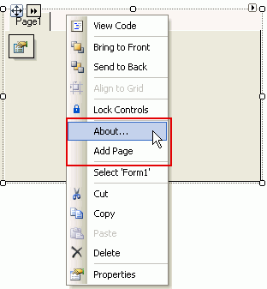

The following table provides a brief description of the custom items added by C1DockingTab
control to its context menu:

Custom Items | Description
About | Opens the About ComponentOne Command dialog box, which is helpful in finding the version number of C1Commandand online resources.
Add Page | Adds a new page to the C1DockingTab.

C1OutBar context menu

Right-click on the C1OutBar control to open its context menu.

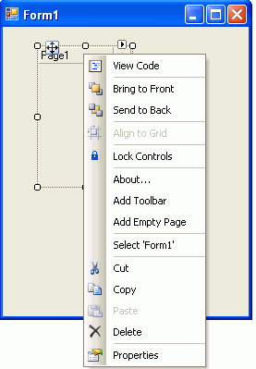

The following table provides a brief description of the custom items added by the C1OutBar control to its context menu:

Custom Items | Description
About | Opens the About ComponentOne Command dialog box, which is helpful in finding the version number of C1Command and online resources.
Add Toolbar | Adds a new C1OutPagewith a C1ToolBarinside it.
Add Empty Page | Adds a new C1OutPage without a C1ToolBar inside it.

C1NavBar context menu

Right-click on the C1NavBar control to open its context menu.

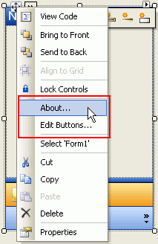

The following table provides a brief description of the custom items added by the C1NavBar control to its context menu:

Custom Items | Description
About | Opens the About ComponentOne Command dialog box, which is helpful in finding the version number of C1Command and online resources.
Edit Buttons | Opens the C1NavBarButton Collection Editor.

C1TopicBar context menu

Right-click on the C1TopicBar control to open its context menu.

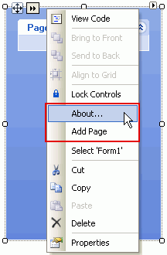

The following table provides a brief description of the custom items added by the C1TopicBar
control to its context menu:

Custom Items | Description
About | Opens the About ComponentOne Command dialog box, which is helpful in finding the version number of C1Command and online resources.
Add Page | Adds a new C1TopicPage to the C1TopicBarcontrol.

Link to Command Designer
C1Command has a Link to Command designer for the command items in the menus and toolbars controls so you can add commands to them or modify existing commands at design time.

To access the Edit designer:

Click on any command item in the menu or toolbar control twice or right-click and select Edit from its context menu to open the Link to Command designer.

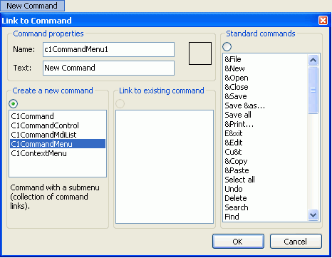

This dialog box is used to create new commands, edit existing ones, or link command links to commands. The same dialog box is used to edit command links in drop-down menus and toolbars. The Link to Command designer contains the following categories: Command properties, Create a new Command, Link to existing command, and Standard commands.

The following table lists and describes the functionality of the items in the Link to Command
designer:

Group Box | Description
Command properties | The Command properties group box includes a Name text box and a Text text box. The Name text box displays the default command name for the command or you can enter a new command name. The Text text box displays the text that appears on the command item.
Create New Command | The Create a new command group box contains a list box of various command types to choose a specific command type for the new command. The radio button enables you to toggle between creating a new command and linking to an

 | existing one in the Link to existing command list box.
Link to Existing Command | The Link to existing command group box displays a list box of commands already created on the form. When you select an item from this list, the Create New Command radio button is automatically unselected.
Standard Commands | The Standard command group box provides 54 built-in commands and 40 images for standard commands. When you select a standard command that includes a built-in image from the Standard commands list box, the preview image appears in the square box located in the Command properties group box.

