Design-Time Support
C1GanttView provides customized context menus, smart tags, and a designer that offers rich design-time support and simplifies working with the object model.

The following topics describe how to use C1GanttView design-time environment to configure
C1GanttView.

See Also

C1GanttView Context Menu C1GanttView Smart Tag

C1GanttView Collection Editors

C1GanttView Context Menu
The C1GanttView control provides a context menu for additional functionality to use at design time.

To access C1GanttView's context menu, right-click on the C1GanttView control and the context menu for it appears like the following:

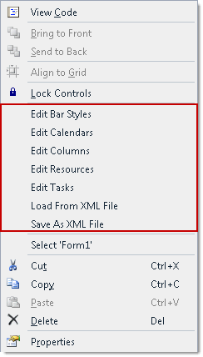

The C1GanttView context menu operates as follows:

- Edit Columns
Selecting the Edit Columns opens the C1GanttView.Columns Collection Editor where you can add, remove, or modify task property columns and custom field columns.
- Edit Calendars
Selecting the Edit Calendars item opens the C1GanttView.CustomCalendars Collection Editor where you can add, remove, or modify calendars.
- Edit Tasks
Selecting the Edit Tasks item opens the C1GanttView.Tasks Collection Editor where you can add, remove, or modify tasks for the C1GanttView control.
- Edit Bar Styles
Selecting the Edit Bar Styles will open the C1GanttView.BarStyles Collection Editor where you can add, remove, or modify bar styles for the bars that represent the milestones.

- Edit Resources
Selecting the Edit Resources item will open the C1GanttView.Resources Collection Editor where you can add, remove, or modify the different types of resources for the ganttview..
- Load From Xml File
Selecting the Load from Xml File opens the Load From Xml File dialog box where you browse to the .xml file you wish to load.
- Save As Xml File
Selecting the Save As Xml File opens the Save As Xml File dialog box where you browse to the .xml file you wish to save.

C1GanttView Smart Tag
In Visual Studio, each component in GanttView for WinForms includes a smart tag. A smart tag represents a short-cut tasks menu that provides the most commonly used properties in each control.

To access the C1GanttView Tasks menu, click the smart tag ( ) in the upper right corner of the
C1GanttView control. This will open the C1GanttView Tasks menu.

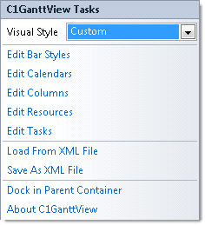

The C1GanttView Tasks menu operates as follows:

Visual Style
The Visual Style dropdown box provides a list of styles to choose from: Custom, System, Office2007Black, Office2007Blue, Office2007Silver, Office2010Black, Office2010Blue, Office2010Silver, and Windows7.

Edit Bar Styles
Clicking Edit Bar Styles will open the C1GanttView.BarStyles Collection Editor where you can add, remove, or modify bar styles for the bars that represent the milestones.

Edit Calendars

Clicking the Edit Calendars item opens the C1GanttView.CustomCalendars Collection Editor
where you can add, remove, or modify calendars.

Edit Columns
Clicking the Edit Columns opens the C1GanttView.Columns Collection Editor where you can add, remove, or modify task property columns and custom field columns.

Edit Resources
Clicking the Edit Resources item will open the C1GanttView.Resources Collection Editor
where you can add, remove, or modify the different types of resources for the ganttview.

Edit Tasks
Clicking the Edit Tasks item opens the C1GanttView.Tasks Collection Editor where you can add, remove, or modify tasks for the C1GanttView control.

Load From Xml File
Clicking the Load from Xml File opens the Load From Xml File dialog box where you browse to the .xml file you wish to load.

Save As Xml File
Clicking the Save As Xml File opens the Save As Xml File dialog box where you browse to the
- ml file you wish to save.

Dock in Parent Container
Clicking Dock in Parent Container allows the C1GanttView control to occupy the entire form.

About C1GanttView
Clicking About C1GanttView shows the About ComponentOne dialog box. This dialog box displays the version number and licensing information for the ComponentOne GanttView product.

C1GanttView Collection Editors
C1GanttView provides the following collection editors that allow you to apply properties to the Ganttviewelements at design time:

  - C1GanttView.Columns Collection Editor
  - C1GanttView.CustomCalendars Collection Editor
  - C1GanttView.BarStyles Collection Editor
  - C1GanttView.Resources Collection Editor
  - CustomCalendar.Workweeks Collection Editor
  - CustomCalendar.CalendarExceptions Collection Editor

The following topics provide an overview of each GanttView collection editor and show how to access each of them:

See Also

BarStyles Collection Editor Columns Collection Editor CustomCalendars Collection Editor
CustomCalendar CalendarException Collection Editor CustomCalendar WorkWeek Collection Editor Resources Collection Editor
Task Collection Editor

BarStyles Collection Editor
Design-Time Support > C1GanttView Collection Editors > BarStyles Collection Editor

The C1GanttView.BarStyles Collection Editor is used for adding different types of bars such as AutoTask, ManualTask, Progress, Milestone, Deadline, DurationOnly, StartOnly, and FinishOnly. Once the bar type is specified you can then modify its shape, pattern, color, and text.

To Access the BarStyles Collection Editor
Right-click on the C1GanttView control and select Edit Bar Styles from its context menu. The C1GanttView.BarStyles Collection Editor appears like the following when a member is added to the collection:

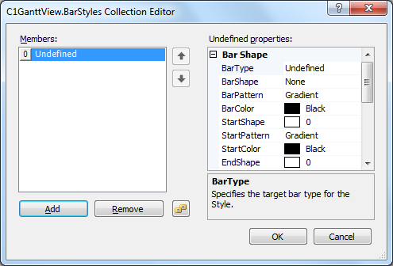

Columns Collection Editor
Design-Time Support > C1GanttView Collection Editors > Columns Collection Editor

The C1GanttView.Columns Collection Editor is used for adding TaskPropertyColumns and
CustomFieldColumns and then modifying its properties at design time.

To Access the Columns Collection Editor
Right-click on the C1GanttView control and select Edit Columns from its context menu. The C1GanttView.Columns Collection Editor appears like the following when a member is added to the collection:

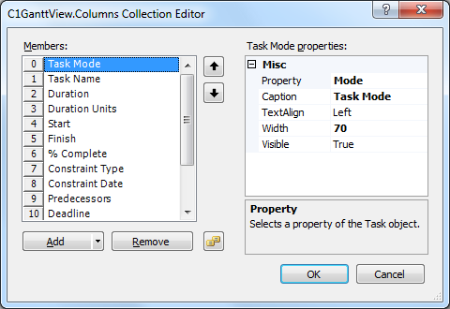

CustomCalendars Collection Editor
Design-Time Support > C1GanttView Collection Editors > CustomCalendars Collection Editor

The C1GanttView.CustomCalendars Collection Editor is used for adding, removing, or modifying custom calendars at design time.

To Access the CustomCalendars Collection Editor
Right-click on the C1GanttView control and select Edit Calendars from its context menu. The C1GanttView.CustomCalendars Collection Editor appears like the following when a member is added to the collection:

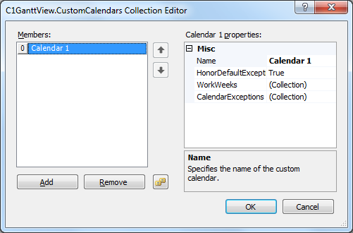

CustomCalendar CalendarException Collection Editor
Design-Time Support > C1GanttView Collection Editors > CustomCalendar CalendarException Collection Editor

The CustomCalendar.CalendarExceptions Collection Editor is used for adding, removing, or modifying exceptions for the custom calendars at design time.

To Access the CustomCalendar.CalendarExceptions Collection Editor
Right-click on the C1GanttView control and select Edit Calendars from its context menu. The C1GanttView.CustomCalendars Collection Editor appears. Click Add to add a new member to the collection. In the properties pane click on the ellipsis button next to CalendarExceptions. The CustomCalendar.CalendarExceptions Collection Editor appears like the following when a member is added to the collection:

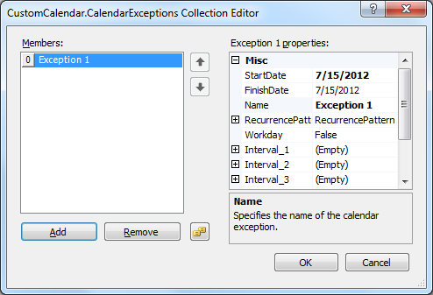

CustomCalendar WorkWeek Collection Editor
Design-Time Support > C1GanttView Collection Editors > CustomCalendar WorkWeek Collection Editor

The CustomCalendar.WorkWeeks Collection Editor is used for adding, removing, or modifying work weeks for the custom calendars at design time.

To Access the CustomCalendar.WorkWeeks Collection Editor
Right-click on the C1GanttView control and select Edit Calendars from its context menu. The C1GanttView.CustomCalendars Collection Editor appears. Click Add to add a new member to the collection. In the properties pane click on the ellipsis button next to WorkWeeks. The CustomCalendar.CalendarWorkWeeks Collection Editor appears like the following when a member is added to the collection:

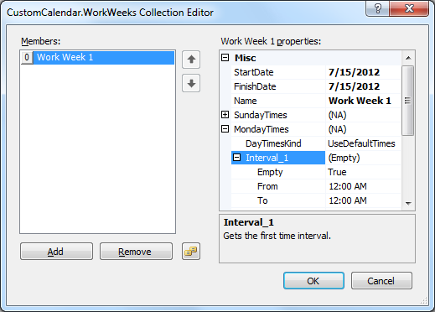

Resources Collection Editor
Design-Time Support > C1GanttView Collection Editors > Resources Collection Editor

The C1GanttView.Resources Collection Editor is used for adding, removing, and modifying resources at design time.

To Access the C1GanttView.Resources Collection Editor
Right-click on the C1GanttView control and select Edit Resources from its context menu. The C1GanttView.Resources Collection Editor appears like the following when a member is added to the collection:

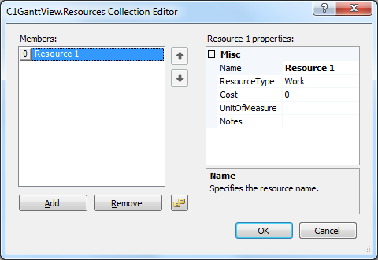

Task Collection Editor
Design-Time Support > C1GanttView Collection Editors > Task Collection Editor

The C1GanttView.Tasks Collection Editor is used for adding, removing, and modifying tasks at design time.

To Access the C1GanttView.Tasks Collection Editor
Right-click on the C1GanttView control and select Edit Tasks from its context menu. The
C1GanttView.Tasks Collection Editor appears like the following:

